Curriculum Vitae for

Mortlake James Kumbemba

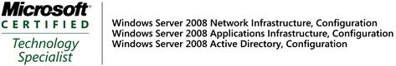

PERSONAL DETAILS

ID Number: MB051361
Current Position: Technical Specialist
Notice Period: Negotiable
Mobile Number 0839743865
Email address: Mortkum@gmail.com
Residential Address: 1 Grace Lane, Peltier Drive,
Sunninghill,2157

OBJECTIVE
I am a service-oriented, customer-centric ICT Systems Engineer with versatile, cross platform experience in IT systems implementation, who is seeking a career that enables me to develop IT solutions to business challenges or problems. I have added Cyber Security to my skills portfolio, and I am actively seeking a consulting opportunity that will enable me to use my subject matter expertise in various facets of IT to find solutions to business challenges. I have acquired extensive training in Cyber Security, Cloud Computing, and Microsoft technologies.

PROFESSIONAL QUALIFICATIONS

CPD – Principles of Software Engineering @ University of Witwatersrand (NQF 8)
CPD – Database Systems @ University of Witwatersrand (NQF 8)
Qualys Certified Specialist – Vulnerability Management (VMDR)
Cybersecurity Specialization certification @ New York University
Cybersecurity A Hands-on Approach Certification @ edX (Carlos III University of Madrid)
OPSWAT Certification - ICIP Critical Infrastructure Protection
COBIT v5 - ISACA
ITIL v3
MCITP – Enterprise Administrator @ Microsoft
Diploma in Information Processing @ Harare Polytechnic

Microsoft Certifications
MCITP: Enterprise Administrator
MCSA – Messaging

New York University - Tandon School of Engineering Qualifications

Introduction to Cyber Attacks
Cyber Attack Countermeasures
Cyber Threat Detection and Mitigation
Enterprise and Infrastructure Security

Carlos III University of Madrid - Coursera Online Training

Cybersecurity basics: A Hands-on Approach

EMPLOYMENT HISTORY

Name of Company: BCX
Period of Employment Jan 2017 to Current
Position Held: Principal Technical Consultant

Platform comprised of a virtual environment running vSphere ESXi 6.5 with Windows server 2012/2016/2019 using MS Active directory for identity and access management. The platform was running a Datawarehouse providing Business Intelligence reports to all government departments, SQL server 2014/2016 was the RDMS used to generate the Business intelligence. The reports were published using Microsoft IIS

Responsibilities:

- Deploy, upgrade, and migrate platforms, systems, and applications.
- Monitor, maintain and support ICT infrastructure, platforms, and technical applications.
- Providing technical leadership to my peers.
- Coordinating problem resolution among a variety of functional areas and providing subject matter expertise support for diagnosing and resolving problems
- Ensuring that all contracted Service Level Objectives and Satisfaction targets are achieved.
- Ensuring that all calls achieve service level targets and quality objectives.
- Ensuring that all platforms are designed, supported, and maintained in accordance with applicable best practice and recommendations.
- Ensuring that all routine monitoring and maintenance tasks are completed according to schedule and to the prescribed standards.
- Ensuring that all open calls are constantly reviewed and updated until call closure.
- To ensure continuous communication to the technical team and feedback regarding escalations to Client Line Management and Users
- Perform the role of a technical leader and serve as mentor for less technical peers.
- Creation and update of technical documentation

Achievements
- Participated in an Infrastructure upgrade project as the primary technical resource where servers, switches, and Storage (SAN) were upgraded to newer models. Virtualization software upgrade from vSphere ESXi 6.5 to 6.7
- Implemented Windows Server upgrade from 2008 to 2012/2016/2019.
- Developed Active Directory integrated FTP server for download of monthly reports for critical government departments.
- Implemented an Offsite DRP site for business continuity in cases of a disaster.

Name of Company: Public Investment Corporation
Period of Employment Oct 2010 to December 2016
Position Held: System Engineer
Responsibilities:

.
- Lead and assist with deployment projects.
- Create and update deployment project plans and schedules.
- The technology platform was Windows Server 2008, later upgraded to 2012 then 2016.
- The relational database platform for the Line of Business application software was SQL Server 2012 later upgraded to 2014.
- Recommending and implementing software or hardware changes to rectify problems or address improvement opportunities.
- Maintain and provide support for Clients Infrastructure Services
- Work with other Engineers, Vendors, and Architects for resolution of issues
- Request technical assistance and escalate when necessary.
- Document, monitor, report, and manage the resolution of issues.
- Recommend procedures and controls for problem resolution.
- Develop and implement workarounds and temporary solutions.
- Create and update technical documentation.

  - Contribute to Knowledge Base Articles
  - Ensuring that all contracted Service Level Objectives and Satisfaction targets are achieved.
  - Ensuring that all calls are logged correctly, updated correctly, followed up, escalated timeously, serviced, and closed with sufficient detail.
  - Ensuring that all calls achieve service level targets and quality objectives.
  - Ensuring that all platforms are designed, supported, and maintained in accordance with applicable best practice and recommendations.
  - Ensuring that all routine monitoring and maintenance tasks are completed according to schedule and to the prescribed standards.
  - Ensuring that all open calls are constantly reviewed and updated until call closure.

Achievements
- Implementation of Microsoft System Centre Operations Manager (SCOM 2010) implementation, support, and administration
- Primary Technical resource in the implementation of Charles River Investment management system support of Microsoft Servers
- Deployment and maintenance of a Disaster Recovery site (DRP) for the purposes of Business Continuity in the case of a disaster.
- Implemented Microsoft Hyper V Virtualization project for consolidation of IT resources such as servers, storage, and networking into a single, virtualized environment. This was done to improve resource utilization, reduction of costs, and increase flexibility.

Name of Company: SITA - (Department of Defense)
Period of Employment Dec 2008 to Sept 2010
Position Held: System Engineer
Responsibilities:

- Primarily responsible for providing 4th line support.
- Server administration of 100 servers in 4 domains running NT4, server 2000 and 2003 in a mixed mode configuration.
- Coordinating problem resolution among a variety of functional areas and providing s subject matter expertise support for diagnosing and resolving problems
- Recommending and implementing software or hardware changes to rectify problems or address improvement opportunities.
- Maintaining and providing support for Clients Infrastructure Services
- Working with other Engineers, Vendors, and Architects for resolution of issues
- Requesting technical assistance and escalating when necessary
- Documentation, monitoring, reporting, and managing the resolution of issues.
- Developing and implementing workarounds and temporary solutions
- Creating and updating technical documentation
- Contributing to Knowledge Base Articles

Achievements:
Acquired the MCITP Enterprise Administrator certification through self-study.
Migrated 5 AD sites from Windows NT to Windows server 2003.

Name of Company: MIT (Mthombo IT Managed Services)
Period of Employment Jan 2007 to Nov 2008
Position Held: System Engineer
Responsibilities:

- Primary role was supporting small to medium sized companies and performing the role of a managed service provider.

- Developing, maintaining, recommending, documenting, and supporting tools and back-end utilities to provide Performance,
- Capacity and Availability management
- Implementation, Optimization and Supporting Application Performance Management
- Performing capacity workload modelling and availability analysis for a variety of platforms and environments using SCOM
- Assessing and analysing availability monitoring metrics and reports to provide recommendations.

Achievement:
- Managed to rebuild an Exchange server 2003 server overnight for the Lesotho Revenue Authority after it had crashed.
- Participated in a Network Security Upgrade project to improve its cybersecurity posture. This involved installing new firewalls, intrusion detection systems, and antivirus software, as well as conducting security assessments and implementing new security policies.
- IT Service Management (ITSM) Implementation: The project involved implementing BMC Remedy software to manage IT services This helped to streamline IT operations, increase efficiency, and improve customer service.

Name of Company: Bytes Technology Group – Outsource Division
Period of Employment: August 2004 to March 2007
Position Held: IT Support Engineer
Responsibilities:

- Installation, configuration, support, and administration of Exchange Server 2003 on HP servers.
- Installation and support of Windows Server 2000
- Investigating and diagnosing Microsoft Exchange 2003 Messaging faults
- Change Management.
- Documenting all major faults that required changes to the system and compiling a knowledge base for future use in case a similar problem arises.
- Event Log Management.
- Administration of the Backup facility.
- Checking key performance indicators, such as free disk space and Exchange message queue lengths for an overall view of the state of the server and configuring the alert features of these tools to set up warnings for any sudden changes or problems and setting baselines to measure performance.
- Checking Antivirus updates on each Exchange 2003 server to ensure that the signature files are up to date.
- Archiving of event logs, archiving data to CD, DVDs according to company security policy.
- Patch Management.
- Configuring and checking that public folder replication is up to date.
- Reviewing SLA performance on a continual basis.
- Reviewing capacity figures for the previous month and producing a plan for any upgrades that may be required in the coming months to keep the system operating within limits specified by the SLA.
- Performing disaster recovery or system recovery for Exchange 2003 servers to test
- Hardware, this would simulate a complete hardware failure for one server.

Name of Company: Standard Bank Chartered Bank
Period of Employment: January 1998 to March 2003
Position Held:
Senior Information Analyst
Information System Analyst
Analyst Programmer

Responsibilities:
Senior Information Analyst (January 2001 to March 2003)
•Attend to daily system problems during and outside normal working hours.
•Develop, test, document and implement solutions.
•Train subordinates and business representatives when need arises.
•Maintain and document various versions of the bank’s core banking systems.
•Rolling out new version of the bank’s core banking systems.
•Escalates system to respective vendors and making follow-ups.
•Maintain a log of system faults and their resolution details.
•Configure Novel servers and workstations to the application’s requirement.
•Ensuring that both the application and the respective hardware were year 2000 compliant.

Information System Analyst (October 1998 to December 2000)
•Supporting the “Bank Master” and “Branch power” core systems which replaced the Zebra system after EMM Project.
•LAN /WAN Support.
•Provide client advice pertaining to usage of applications and equipment and call registering.
•Network infrastructure design.
•Preventative Maintenance (including pro-active identification of IT problems)
•Virus Control.
•Monitor workstations capacity and workload utilization.
•Technical document compilation using MS Word, Excel and Visio.
•Compilation of month reports, standby reports and tendency reports.
•Installation and configuration of Front Office Banking Software to a branch network
•Pre and Post implementation training of users on the new software.
•General support of the system on daily administrative issues i.e. telephonically or onsite.
•Quarterly system upgrade.
•Management of a Disaster Recovery Test site where a copy of the “Live” system is kept.

Additional Training / Courses

LinkedIn Online Training and Qualifications
Artificial Intelligence for Cybersecurity
Threat Modelling for Security Professionals
Soft Skills for Information Security Professionals
Securing Containers and Kubernetes Ecosystem
Cybersecurity with Cloud Computing
Learning SSL/TLS
Learning Vulnerability Management
Learning Computer Forensics
IT Security Foundations: Network Security
IT Security Foundations: Core Concepts
IT Security Foundations: Operating Systems
Cybersecurity Foundations
Blockchain Basics (2017)
Blockchain: Learning Solidity
Cryptocurrency Foundations
Securing Cryptocurrencies
Ethereum: Building Decentralized Apps (DAPPS)
Blockchain: Beyond Basics

CYBRARY TRAINING and QUALIFICATIONS

ISC2 CRISC
ISC2 CISSP
Incident Response and Advanced Forensics
Computer Hacking and Forensics
Penetration Testing and Ethical Hacking
Practical Project Management
Fundamental Systems Security
Security Operations

COMPUTER SKILLS / TECHNOLOGIES

LAN/WAN support (TCP/IP)
Technical Support and Administration of Microsoft Server Technologies
Technical Support and Administration of VMware VSphere servers
Technical Support and Administration SQL Server 2008/2014/2016
System Centre Operations Manager (SCOM 2012) Administration
Microsoft Hyper V Virtualization Technology Support and Administration
Microsoft .NET Framework
Visual Studio.Net

Skillsoft Training badges

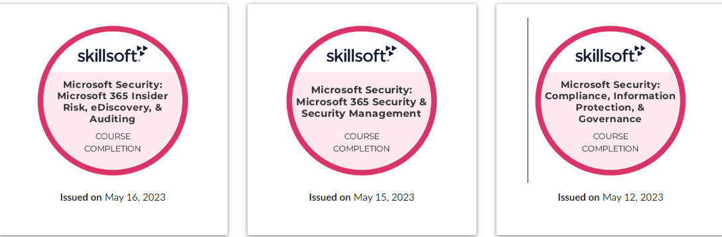
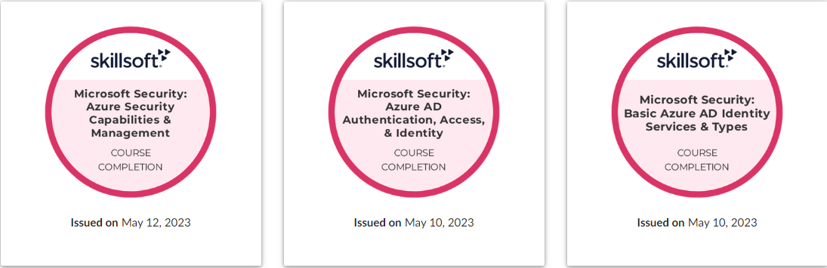

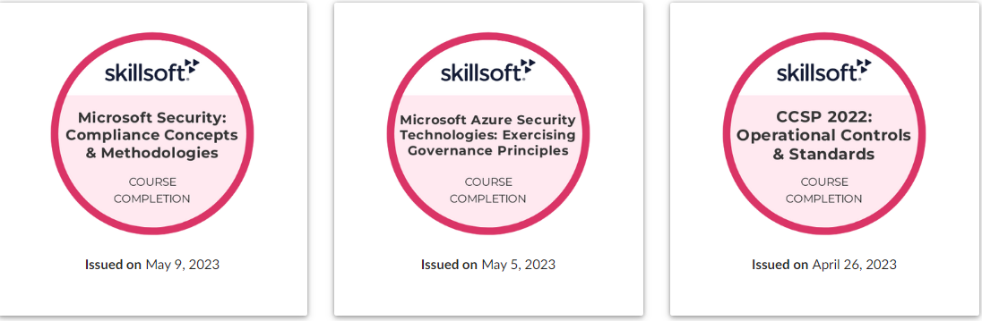

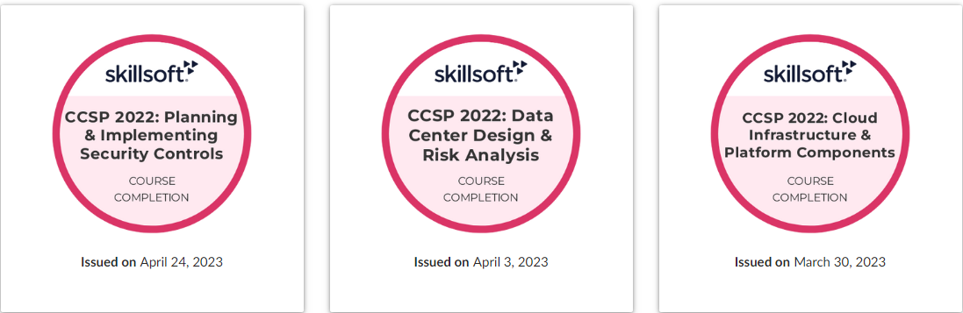

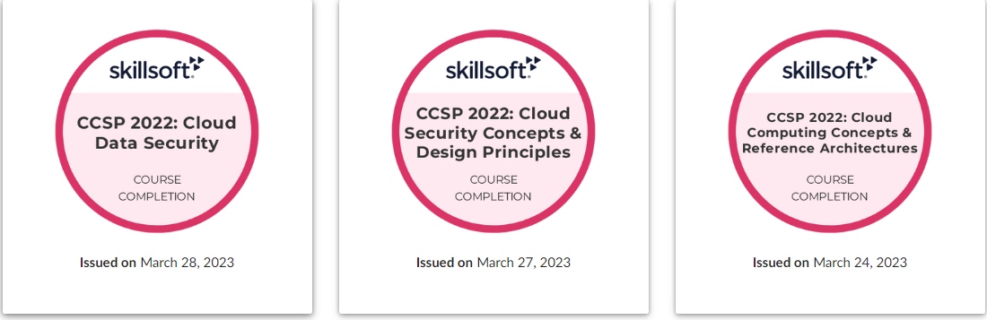

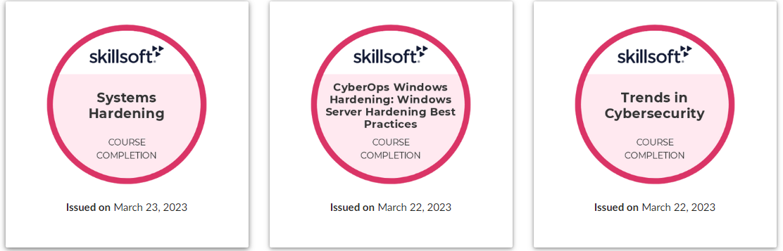

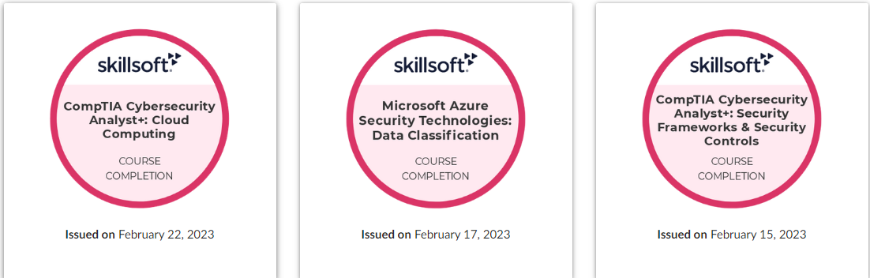

REFERENCES

To be furnished upon request

