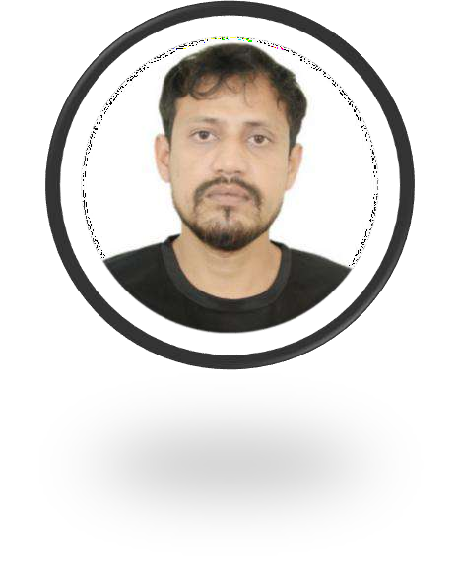
SADDAM ADIL
Senior Digital Marketing Executive
! +91 9634999558 | ʌ•V □ saddam.adil653@gmail.com
•˙¡ New Delhi, India | LinkedIn | My Blog

Professional Summary
Results-driven Digital Marketing Executive with 6+ years of experience in crafting data- driven strategies to boost brand visibility, engagement, and ROI. Proven track record in increasing organic traffic by 50%+ through SEO, scaling paid campaign efficiency by 30%, and leading cross-functional teams for global clients. Expertise in omnichannel marketing, analytics, and client relationship management. Fluent in English, Hindi, and Urdu.

Key Achievements
- Increased organic traffic by 60% for MAT Living USA through SEO optimization.
- Reduced customer acquisition cost (CAC) by 25% via Google Ads campaign restructuring.
- Grew social media engagement by 40% for Signature Smile Digital Solutions through targeted content strategies.
- Launched 6+ successful client projects, driving an average of 20% 2022-2023 revenue growth.

Work Experience
Sr. Digital Marketing Executive
Crest Group (Parent Company) | Aug 2022 – Present | Ahmedabad, India
Leading cross-industry digital strategies for subsidiaries in chemical, FMCG, and IT sectors:

Crest Speciality Resins (Chemical Division)
- Boosted organic traffic by 20% 2024-2025 via technical SEO audits and multilingual campaigns (English/Arabic) targeting Middle Eastern/European industrial clients.
- Collaborated with RCD to publish 12+ whitepapers, ranking for 50+ niche keywords (“epoxy resins for automotive composites”).

- Reduced cost-per-lead by 10% through LinkedIn Ads and Google Display Network retargeting.

Longbow Food s Beverages (FMCG Division)
- Drove 10% engagement growth on Instagram through Reels and micro-influencer partnerships, increasing e-commerce revenue by 5%.
- Optimized 30k/month Meta Ads budgets, achieving .70x ROAS with dynamic creatives and audience segmentation.
- Executed Raksha Bandhan/Diwali campaigns with localized content, generating 100k+ impressions and a 5% uplift in conversions.

Lynkersoft (IT Solutions Division)
- Increased free-to-paid conversions for Tasksay Business Suite by 3% via email automation and personalized onboarding workflows.
- Grew organic traffic 15% YoY through G2-optimized case studies and SaaS- focused blogs, securing a Top 5 HR tech ranking.
- Slashed Google Ads CPA by 5% using Smart Bidding and SEMrush competitor gap analysis.

Digital Marketing Executive
OCDS Advertising PR Ltd., Mumbai | Sep 2021 – Aug 2022
- Led end-to-end digital strategies for 6 clients (VijayBhoomi University, Signature Smile, BetSetWin), achieving a 35% average increase in lead generation.
- Improved organic traffic by 35% via technical SEO audits and on-page optimization using SEMrush.
- Optimized Google Ads campaigns, reducing CPC by 18% and increasing CTR by 22%.
- Collaborated with designers to create social media calendars, boosting engagement by 20% across platforms.

Digital Marketing Executive
M A Trading Inc. | July 2019 – Sep 2021
- Directed SEO and PPC campaigns for MAT Living USA/India, improving keyword rankings for 150+ terms.
- Cut CAC by 25% through A/B testing of ad creatives and audience targeting on Google Ads/Bing.

- Partnered with 10+ influencers, increasing affiliate revenue by 35% for home furnishing brands.

Education
- B.Sc. (Hons) Physics | Aligarh Muslim University | 2012–2015
- Diploma in Advanced Digital Marketing | DSIM | 2016
- Diploma in Computer Applications (ADCA) | MJPRU | 2015
- Diploma in Urdu Language | NIUL | 2014

Skills
Core Competencies: SEO/SEM, Social Media Strategy, PPC, Content Marketing, Data Analytics
Tools: Google Ads, Meta Business Suite, SEMrush, Ahrefs, Google Analytics, WordPress, Shopify, Mailchimp, Klaviyo,

Certifications:
- Google Ads Certification (2019)
- HubSpot Content Marketing Certification (2020)
- Meta Blueprint Certification (20)

Languages
- English (Fluent) | Hindi (Native) | Urdu (Proficient)

